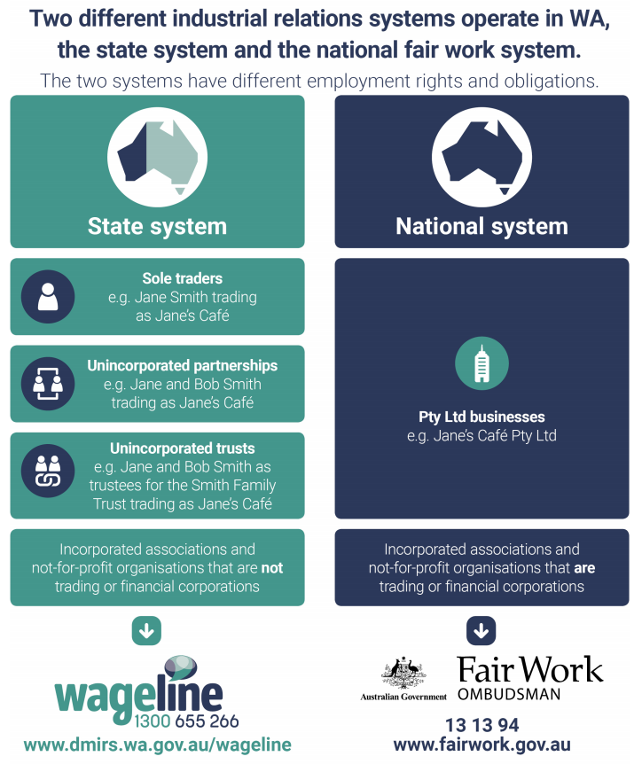
Source https://www.commerce.wa.gov.au/labour-relations/guide-who-wa-state-system
State employment laws that apply to federal system employers and employees
The Western Australia Long Service Leave Act (1958) applies to most employers and employees under the federal Fair Work system.
Western Australia’s Children and Community Services Act (2004) provisions on paid and unpaid work by children under 15 years of age and Work Health and Safety Act (2020) apply to all employers in the State.
National Employment laws that apply to state system employers and employees
Fair Work Act (2009) provisions on notice of termination and parental leave apply to employers and employees operating under State employment laws.

